TFAF Work plan 2024

|  |
| --- |
| **Current TFA Implementation State of Play[1]**  The WTO Trade Facilitation Agreement (TFA) entered into force on 22 February 2017, when more than two-thirds of the WTO membership had ratified the [Protocol of Amendment](https://docs.wto.org/dol2fe/Pages/SS/directdoc.aspx?filename=Q:/WT/L/940.pdf) to the WTO.[2] No additional ratifications were received in 2023 giving a total of 156 WTO Members' ratification representing 95.1% of the total WTO membership.  In terms of notifications under Section II of the TFA, 87 **developing Members** (97%) have presented their Category ABC designations. Over 95% of developing Members have presented notifications of definitive dates for the implementation of their Category B and C designations, and details on their technical assistance and capacity building (TACB) needs required to implement their Category C designations.  Thirty-two **LDC Members** (91%) have presented their Category ABC designations. Twenty-nine LDC Members (91%) have presented all of their TACB requirements. Ninety-seven percent have presented definitive dates for the implementation of Category B and 84% for Category C designations.  A full and up-to-date analysis of all ratifications and notifications can be found on the TFA Database.[3] These notifications inform the TF Committee, the Trade Facilitation Agreement Facility (TFAF) and trade facilitation stakeholders-at-large of Members' TFA implementation progress, anticipated timelines and assistance needs.  The implementation rate, measured by the definitive dates submitted with the notifications, is currently 77% globally with developed Members implementing at a rate of 100%, developing Members implementing at a rate of 80%, and LDC Members implementing at a rate of 44%.[4]  The majority of the implementation dates notified for categories B and C are spread out over the next five years. Supporting Members to identify implementation support for these impending Category C notified definitive dates is therefore a clear focus for the work of the Facility in the coming years. |

# work plan Overview

In line with the Framework for the Management and Operation of the Trade Facilitation Agreement Facility (document [G/TFA/3](https://docs.wto.org/dol2fe/Pages/FE_Search/FE_S_S006.aspx?MetaCollection=WTO&SymbolList=%22G%2fTFA%2f3%22+OR+%22G%2fTFA%2f3%2f*%22&Language=ENGLISH&SearchPage=FE_S_S001&languageUIChanged=true)), this document sets out the work plan for the Facility for the year 2024.

Preparation of the plan was carried out with the TF Committee both via its direct inputs and via the representative group of Members that is made up of 15 representatives of 12 WTO Members. The participating Members include Botswana (on behalf of LLDC Group), China, Ecuador, EU (2 representatives), Jamaica, Mozambique (on behalf of LDC Group), OECS Secretariat, Peru, Togo, UK, US (3 representatives) and Zimbabwe.

It was drawn up based on:

Modes of delivery as set out in the Operational Guidelines and Framework;

Priorities identified by the Committee as conveyed during a formal meeting held before mid‑year, under a specific agenda item entitled "The Facility Work Plan";

Follow-up meetings with the representative group of Members;

Trade facilitation needs identified in the biennial Institute for Training and Technical Cooperation (ITTC) survey of Members' technical assistance needs as well as needs identified in Category C notifications; and

Activities proposed by partner organizations.

The biennial survey (d.) identified very broad priorities relating to trade facilitation with continuous requests across all regions for technical assistance needs relating to the TFA. Discussions are on-going with the WTO Institute for Training and Technical Cooperation (ITTC) to enhance the next survey with more focused questions on TF to capture emerging TFA needs.

A draft of this work plan was discussed during the annual dedicated session on assistance and capacity building of the CTF held on 5 October 2023, under agenda point 4. Members of the Committee had the opportunity to comment on the priorities and activities proposed in the draft and to propose additions. Following these discussions the TFAF prepared an updated draft and submitted it to the representative group of Members for approval/endorsement. This final document is now issued by the deadline of end November.

In addition to the proposed activities foreseen in section 3 of this work plan, the TFAF will also accept activity requests[5] to be submitted throughout the year by Members. These requests are dealt with by the TFAF team in line with the procedures described in [JOB/TF/231](https://docs.wto.org/dol2fe/Pages/FE_Search/FE_S_S006.aspx?MetaCollection=WTO&SymbolList=%22JOB%2fTF%2f231%22+OR+%22JOB%2fTF%2f231%2f*%22&Language=ENGLISH&SearchPage=FE_S_S001&languageUIChanged=true). This allows for a needs-driven approach to emerging issues.

Any Member that has requested[6] a username and password for the online activity tracker has access to the activity request form. An email is sent to these Members to inform them when a new activity is posted. Members are generally given two weeks to comment on the request before TFAF can commit to conduct the activity.

Details on all upcoming activities and feedback on recently completed tasks, whether foreseen in this work plan, or proposed via the activity request form, are communicated to stakeholders via regular updates throughout the year; notably in regular reports to the WTO Trade Facilitation Committee and in a comprehensive annual report.

To make progress towards these goals, in 2024 the Facility, in cooperation with development partners, will deliver activities and outputs through its four modes of delivery:

Modes of Delivery

Grant Program: The Facility administers a grant program: The procedures of the grant program are established in its Operational Rules.[7] And more information is available on its website.

Technical Assistance and Capacity Building: The Facility responds to requests from developing Members and LDC Members for technical assistance and capacity building on the Agreement.

Engagement with Annex D and Development partners: The Facility maintains close contact with Annex D and Development partners to share information and allow for coordination and non-duplication of efforts on trade facilitation.

Maintain the Facility website: The TFAF maintains and further develops its website to ensure that it constitutes a comprehensive information sharing/exchange platform.

The TFAF pays special attention and prioritizes the needs of LDC Members. In line with development partners' priorities, it also endeavours to enhance the participation of women in all TFAF-organized activities.

The activities carried out by the TFAF will be conducted respecting the Paris Principles of Aid Effectiveness, namely ownership, alignment, harmonization, managing for results and mutual accountability.

# Priorities for 2024

The representative group of TF Committee Members identified the following topics that should be considered as priorities in 2024:

Transit.

Capital-based officials' participation in dedicated session, emphasizing donor engagement and coordination.

Issues identified in the context of the 5th Anniversary of the TFA event and 4-year review of the TFA.

Top 5 measures for implementation in 2024-25 (as identified by notified definitive dates of implementation).[8]

National Trade Facilitation Committees: Incorporating strategies for private sector engagement.

Support for regional coordination.

Implementation of TFA to improve Humanitarian Assistance and Disaster Preparedness.

Inclusion of priorities in this work plan should not be understood as a commitment by TFAF to ensure implementation of related TFA articles. Some priorities will be supported through the delivery of directly associated activities (see table in section 3.7), while others will be supported by TFAF through its website, coordination of partner efforts and by monitoring and reporting to the Committee.

Additional activities may be proposed by Members throughout the year via the activity request form, they will be asked to identify contributions to the priorities.

Experts engaged to deliver support through the TFAF Grant Program are also prompted to identify alignment of their work with the priorities.

Activities and grants will be monitored throughout the year to measure their impact. When the annual report for 2024 is prepared, a section will identify the specific outputs of TFAF activities that have contributed to making progress on the priorities.

# activities

The following activities, in line with the four modes of delivery, will be organized in 2024:

Grant program

The grant program[9] provides for project preparation and project implementation grants for Members that are unable to find the assistance needed to implement provisions designated in Category C. The first step of the process is the submission of an Expression of Interest (EoI) form detailing the assistance needs and steps taken to seek support. This information is circulated to development partners to attempt to find implementation support and to avoid duplication with existing assistance programmes. If no partner offers to assist with implementation, the applicant is eligible to apply for a TFAF grant.

Further work will take place throughout 2024, to strengthen the grant program's responsiveness to TFA implementation needs. To increase the awareness and understanding of the grant program's application procedures presentations on these topics will be included at events organized and attended by TFAF throughout 2024.

The TFAF will provide updates on the grant program at each meeting of the WTO Trade Facilitation Committee.

During the Committee meeting in October, TFAF held bilateral meetings on TACB needs with 24 Members. Following these meetings, 15 expression of Interest (EoI) and three applications for Project Implementation Grants (PG), following up on previous Project Proposal Grants (PPGs) will be drafted. The table below shows the current estimate of expected EoI and PG applications.

|  |  |
| --- | --- |
| EoI | 15 (Angola, Cambodia, Cameroon, Congo, Ghana, Jordan, Lao PDR, Mali, Myanmar, Nepal, Nicaragua, Niger, Senegal, St. Lucia, Tanzania) |
| Project Implementation Grants (PG) | 3 (Grenada, Guyana, Kyrgyz Republic) |

Technical assistance and capacity building

The TFAF TACB activities relate to the following outcomes from the TFAF log frame (Annex 1[10]): identifying implementation assistance, ratification of the Agreement, notifications under the Agreement, and strengthening the operation of National Trade Facilitation Committees. Activities in 2024 are divided between those that are priority-driven (identified in section 2 above) and those stand-alone activities that are not directly associated to a specific priority, but that contribute to TFAF's overall mandate.

The TACB activities in 2024 are delivered through training and sensitization workshops and TFAF experience exchanges that allow Members to share information on good trade facilitation practices and learn from each other. TFAF organizes these activities in partnership with the Annex D and other implementing partners.

| Priority | Activity |
| --- | --- |
| **Transit** | Activities to follow up the 2023 TFAF Transit workshop. Additional topics to be explored include cooperation on Authorized Operators along transit corridors, and donor coordination on transit issues.  This may include funding of capital-based delegates to participate in the CTF dedicated session on Transit. |
| **Capital-based officials' participation in dedicated session** | TFAF to fund capital-based officials to attend the CTF meeting with dedicated session on technical assistance and support for capacity building.  Activities to support matchmaking and engagement with donors and development partners. |
| **Issues identified in the Anniversary event and 4-year review** | Knowledge work on thematic topics. Example: exploring digitalization, implementation of smart border management, connectivity and narrowing the digital divide in the context of implementation of the TFA. |
| **Top 5 2024-25**  **(Definitive dates)** | Based on Members' requests and notifications.  Jamaica: Training for border officials on coordinated inspection practices (Article 8) |
| **Support to National Trade Facilitation Committees** | Cooperating with development partners on support to and tools for enhancing the role of national trade facilitation committees and strengthening private sector engagement, through capacity building, data collection on status of NTFC, and best-practice sharing.  Jordan: Training for the NTFC on international export and import controls. |
| **Support for regional coordination** | Regional activities have been requested by the following:  [CARICOM, ECOWAS, ALADI, SADC]  The regional activities will address specific thematic implementation needs and support regional coordination for the TFA implementation. |
| **Implementation of TFA to improve Humanitarian Assistance and Disaster Preparedness** | Activities in view of promoting the implementation of TFA to improve Humanitarian Assistance and Disaster Preparedness (communication with traders including enquiry points, border agency cooperation, review of formalities and border procedures). |

Stand-alone activities

Stand-alone TACB activities may be conducted to support specific Member's TFA implementation needs. The support can be delivered by training and sensitization, short-term legal or expert advice, or peer-to peer learning and experience sharing.

Four Members (Democratic Republic of Congo, Mauritius, Sri Lanka, and St. Vincent and the Grenadines) have expressed needs for such activities.

Engagement with Annex D and Development partners

|  |  |
| --- | --- |
| Activity | Detail |
| **Upon invitation, TFAF will participate in sessions hosted by partner organizations** | Based on lessons learned, the aim of this participation will be to strengthen the coordination of TFA implementation efforts. Participation in external events has proven to be a cost-effective method to widen the TFAF's reach to deliver an accurate, consistent, and aligned message on the TFA and the Facility, without the need to dedicate the necessary resources to organize and host national and regional events in all locations globally. |
| **Co-host activities with partner organizations** | As above, when appropriate, TFAF will co-host activities with partners in order to bring together the appropriate expertise according to the needs of Members and to achieve cost-efficiencies compared to hosting alone. |

In 2024, TFAF will continue to organize meetings with the Annex D and other development partners to strengthen coordination of TFA implementation efforts, build partnerships for delivering TACB activities, avoid duplication, and support matchmaking of Members' TFA implementation needs.

The TFAF will participate in TFA-related events organized by other international or regional organizations, national governments, and private sector associations; virtual participation is prioritized where feasible.

Website

The TFAF website has a key role in to disseminating information on the Trade Facilitation Agreement and its requirements. The TFAF will continue awareness raising on website streamlined in TFAF organized activities. TFAF will explore venues to collect user feedback in view of enhanced functionalities. Maintenance and development will make up the majority of costs related to the website.

# Monitoring and evaluation

The activity and reporting cycle of the TFAF.



# Risks

The Facility faces a risk to the timely execution of the grant program due to administrative processes and procurement rules within the WTO, and slow responsiveness on the Member side. To mitigate this risk, the Facility will ensure that the project scope is clear, realistic and aligned with Members' expectations. Furthermore, the Facility will identify a critical path of minimum tasks to ensure delivery of each project and monitor the execution closely.

The Facility also faces constraints on its funding resulting in the prospective risk that not all planned activities can be carried out in 2024. To address this risk, the Facility will consult with the Committee through the representative group to identify activities to be prioritized. The Facility will review its approach to fund raising under guidance from the Committee.

External shocks, such as natural disasters and political crisis, are ongoing risks for many Members and they are a persistent risk to the implementation of TFAF activities.

# Draft budget

|  |  |  |
| --- | --- | --- |
| **ACTIVITY** | **NUMBER** | **UNIT AMOUNT**  **IN CHF**  **(TOTAL)** |
| Delivery Mode A: Operation of TFAF grant funding program - Project preparation grants | 3 + applications received during the year | 28,000  (84,000) |
| Delivery Mode A: Operation of TFAF grant funding program - Project implementation grants | 11 + applications received during the year | 180,000 (2,000,000) |
| Numbers reflect number of current EoIs and prospective PGs (see 3.5) The actual number may be lower when and if donors and implementing partners match EoI through their programmes and projects | | |
| Delivery Mode B: Technical Assistance and Capacity Building: National activities (see 3.7 and 3.9)  (Cost estimate is based on in-person delivery) | 6 + activity requests received during the year | 20,000 (120,000) |
| Delivery Mode B: Technical Assistance and Capacity Building: Regional (or sub-regional) activities  (Cost estimate is based on in-person delivery) | Full scale (200'000)  Minimal scale (50'000) | 50,000 |
| Delivery Mode B: Technical Assistance and Capacity Building: National needs assessments  (Cost estimate is based on in-person delivery) | [1] + activity requests | 20,000 |
| Delivery Mode B: Technical Assistance and Capacity Building: Matchmaking events and thematic knowledge work activities  (Cost estimate is based on in-person delivery)  Funding Capital based officials  Transit meeting (30 LLDC capital-based officials)  Dedicated session (40 LDC capital-based officials) | 2 + activity requests  1  1 | 20,000  110,000  150,000  (280,000) |
| Delivery Mode C: Engagement with Annex D and Development partners | 5 + activity requests | 6,500  (32,500) |
| Delivery Mode D: TFAF Website  Maintenance and development | 1 | 15,000 |
| Staff Member at grade 7 position  Monthly salary, insurance, and pension  Staff Member at grade 9 position  Monthly salary, insurance, and pension  Internship for Graduate Student  (Cost estimate is based on possibility to host intern) | 1  1  1 | 175,000  200,139  5,000 |
| **TOTAL (estimates for known costs. Not including additional grants and activity requests)** |  | 2,981,639 |

Note: Interested Members will be notified of activity requests and expressions of interest, as submitted throughout 2024, and can therefore monitor ongoing expenditure beyond that foreseen in this budget.

**Annex 1[11] - The TFAF Log frame**

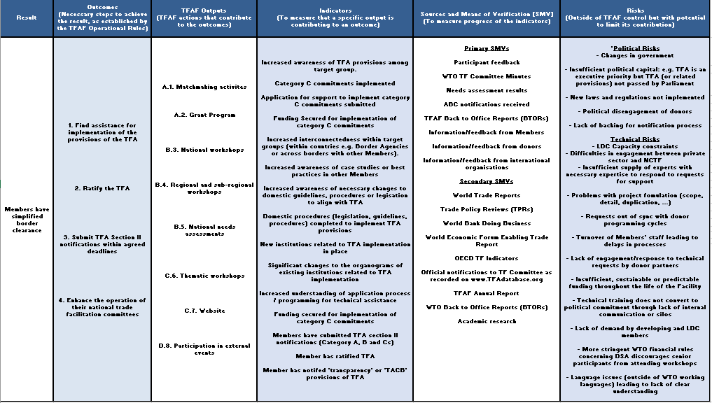

**_________**

1. All implementation statistics are correct as of 19 September 2023 on <http://www.tfadatabase.org>.
2. The Protocol Amending the Marrakesh Agreement Establishing the World Trade Organization done at Geneva on 27 November 2014 (WT/L/940).
3. <https://www.tfadatabase.org/notifications-matrix>.
4. Based on notifications provided to date.
5. [TFAF-TA -Activity Request Form - Formstack](https://wto.formstack.com/forms/tfaf_ta_virtual)
6. Via email request to [TFAF@WTO.org](mailto:TFAF@WTO.org).
7. <https://www.tfafacility.org/assistance-grants/tfaf-grant-program>.
8. [Due Implementation commitments by dates | TFAD - Trade Facilitation Agreement Database (tfadatabase.org)](https://www.tfadatabase.org/en/implementation/commitments-due-by-date).
9. [TFAF Grant Program | TFAF (tfafacility.org)](https://www.tfafacility.org/assistance-grants/tfaf-grant-program).
10. In English only.
11. In English only.